LOCAL- PEACE AGREEMENTS

Link to website: http://107.151.193.203/ct/
Link to video: https://youtu.be/I6JvIOWEdXc

Introduction & audience
Our project is building an interactive website centered on data extraction from the Local Peace Agreement. Moreover, the target audiences we are aiming at are socialists, researchers, potential mediators and peace-loving people.

The dataset of our project is about local peace agreements. It lists all agreements included on the main PA-X database that deal in some way with local issues. The detailed database covers 25 countries in the Asia-Pacific region, Middle East and North Africa, Europe and Eurasia, Africa(excl MENA) and Cross-regional five regions between 1990 and 2020.The signing of the local peace agreement will promote peace between the regions. In situations where national level peace processes become stalled, local peace processes may present an alternative opportunity to address violence in the interim.

Discussing about the plan of how we structured our website in order to implement the information we collected from further researches after doing data analysis,we constructed a script that simp ly guide the users through in a web browser as following.

1) Let users notice the conflicts around the world and local peace agreements and have a better understanding of the world peace process.
2) Draw users’ attention to more than forty percent of the world's local peace agreements that are signed in the Middle East, in order for them to focus on this particular region.
3) Be able to gain more insights on specific analysis and data presentation about the Middle East in terms of its local peace agreements signed in the past.
4) There is explicit information organized that displayed on the slide by clicking on our Analysis Report. Users will learn about specific analyses of mediators and local peace agreements.

Research Question
The information about our analysis content can be exclaimed into two major sections, the overview and the individual reports, in which the later one can be found on the website that we created. While in this report, we would like to focus on some of the researches we investigated in the overview section.

In assignment 2, we carried out some basic analyses of the data, such as agreement definition and status, agreement stage, location of these countries, local agreement properties and mediator. Some of our conclusions were drew below.

1) Local peace agreements mainly signed by Africa and Middle East countries. 2)The number of local peace agreements surged after 2013, and peaked at 2018. 3) (PT)Evidence of a clear culture or practice of local peace agreement mainly located in Middle East and North Africa. 4) Different regions tend to have different mediators.

These basic analysis inspired us to think more about what might be behind the relationships and distributions that we have found? We decided to mainly explore the following three questions. 1) Does the number of local peace agreement affect the number of wars? 2)How does mediator affect peace agreements and local peace? 3)What factors might affect the type of mediator? For instance, we made a hypothesis on whether the choice of mediator is influenced by culture, regional economy and state of national government. The picture is shown in Fig.1.

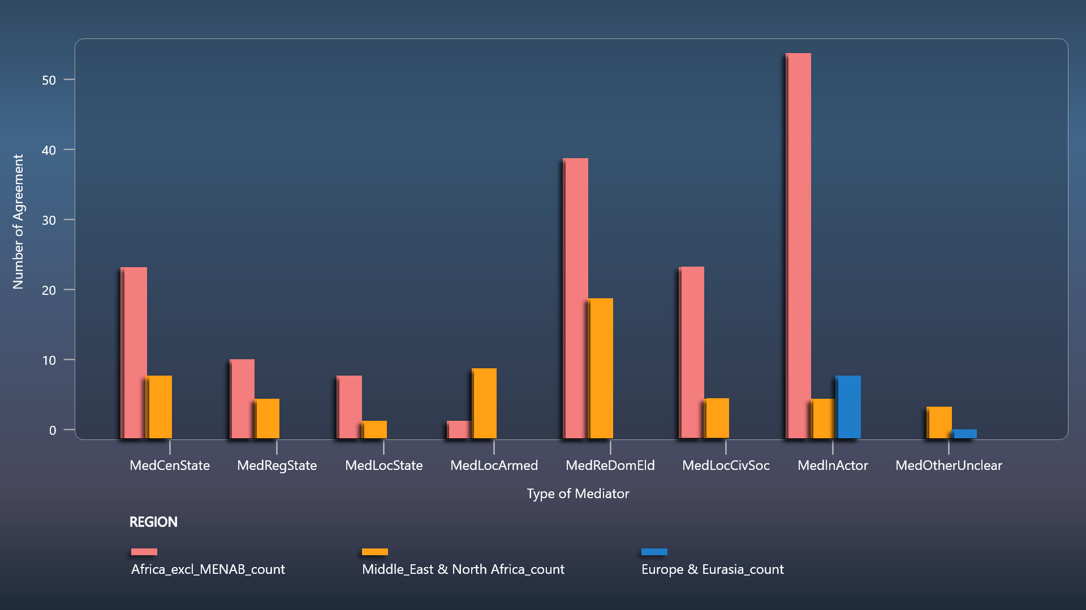

Fig.1 The relationship between the number of peace agreements signed and the eight different types of Mediators showed in three regions.

Data Visualization and Analysis
We did data analysis, visualization and some relevant research towards the 3 questions above.
For question 1, while examining the data from the peace agreement, there was a surge in the local peace agreements after a certain point of time. Hence, we decided to investigate the reasons for causing this surge(Fig.2).

We created three possible hypotheses as following.
1) People's awareness of peace has increased. 2) The increases in regional conflicts. 3) External forces involved.

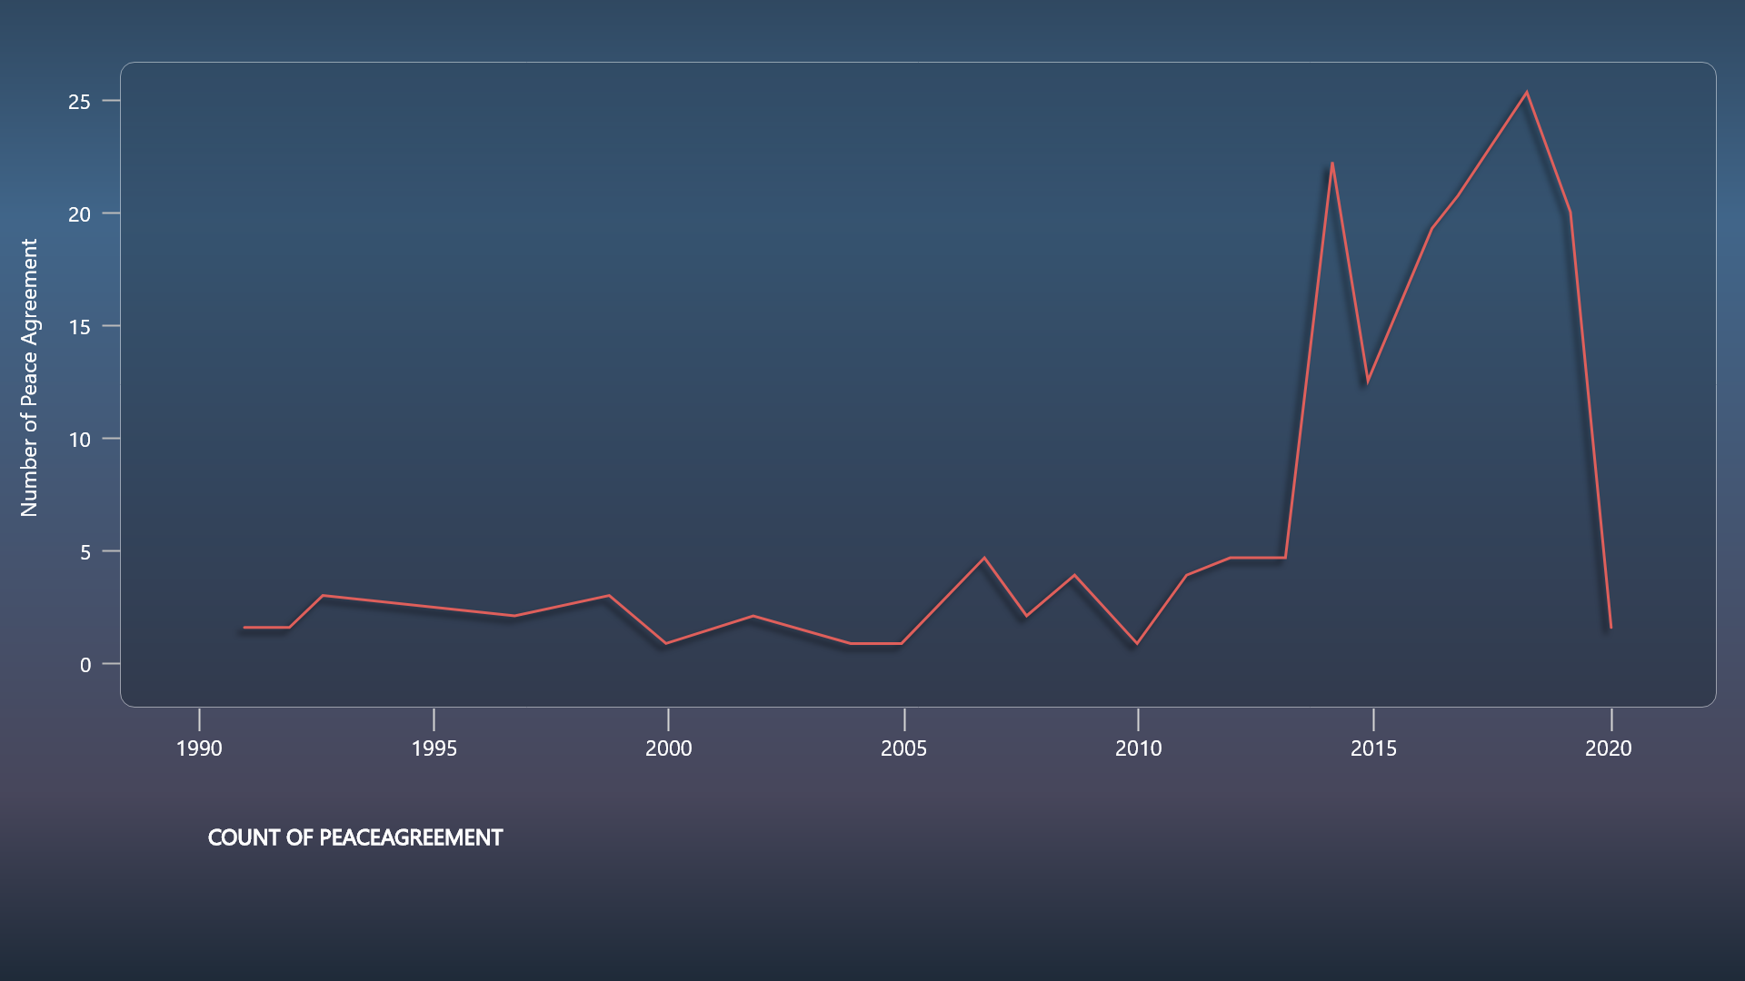

Fig.2 The number of peace agreements signed between 1990 and 2020.

Based on the research and hypotheses towards question 1, we made a timeline with important timepoint and figured the relationships between the number of peace agreements signed based on countries (Fig.3), then exclaimed four nations that had the most agreement signed from 1999 to 2020 (Fig.4). We could see peaks of percentage of local peace agreements usually mean the beginning of wars or a new stage of wars.

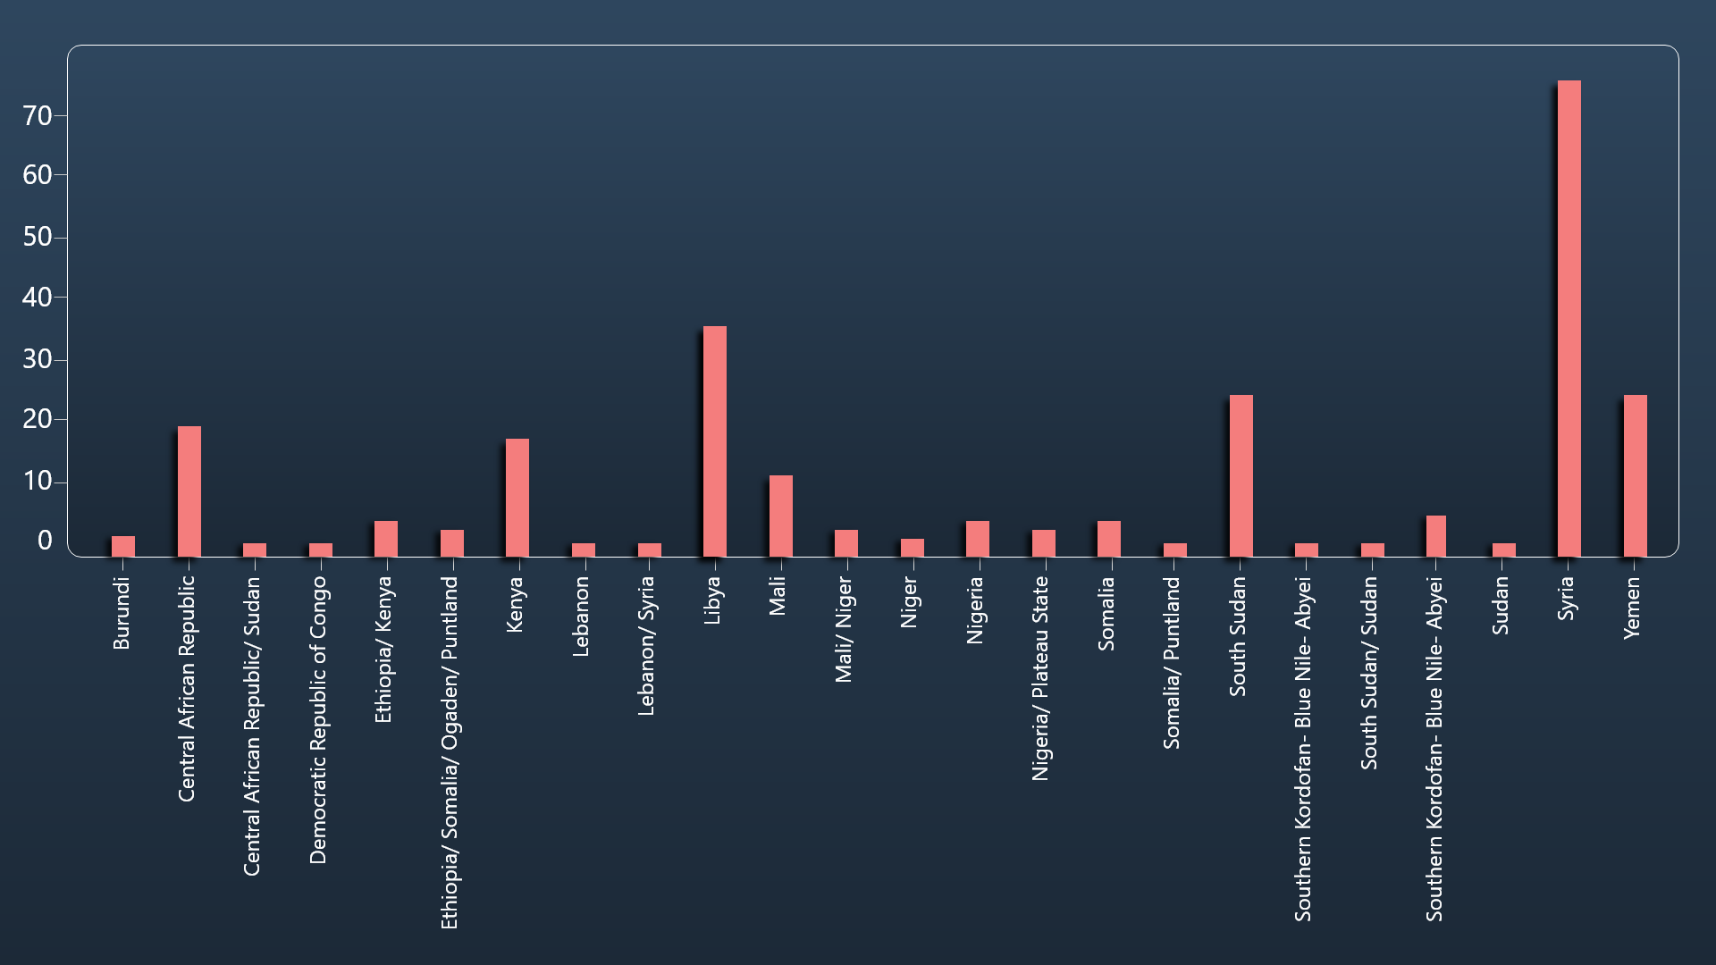
Fig.3 The number of peace agreements signed based on countries.

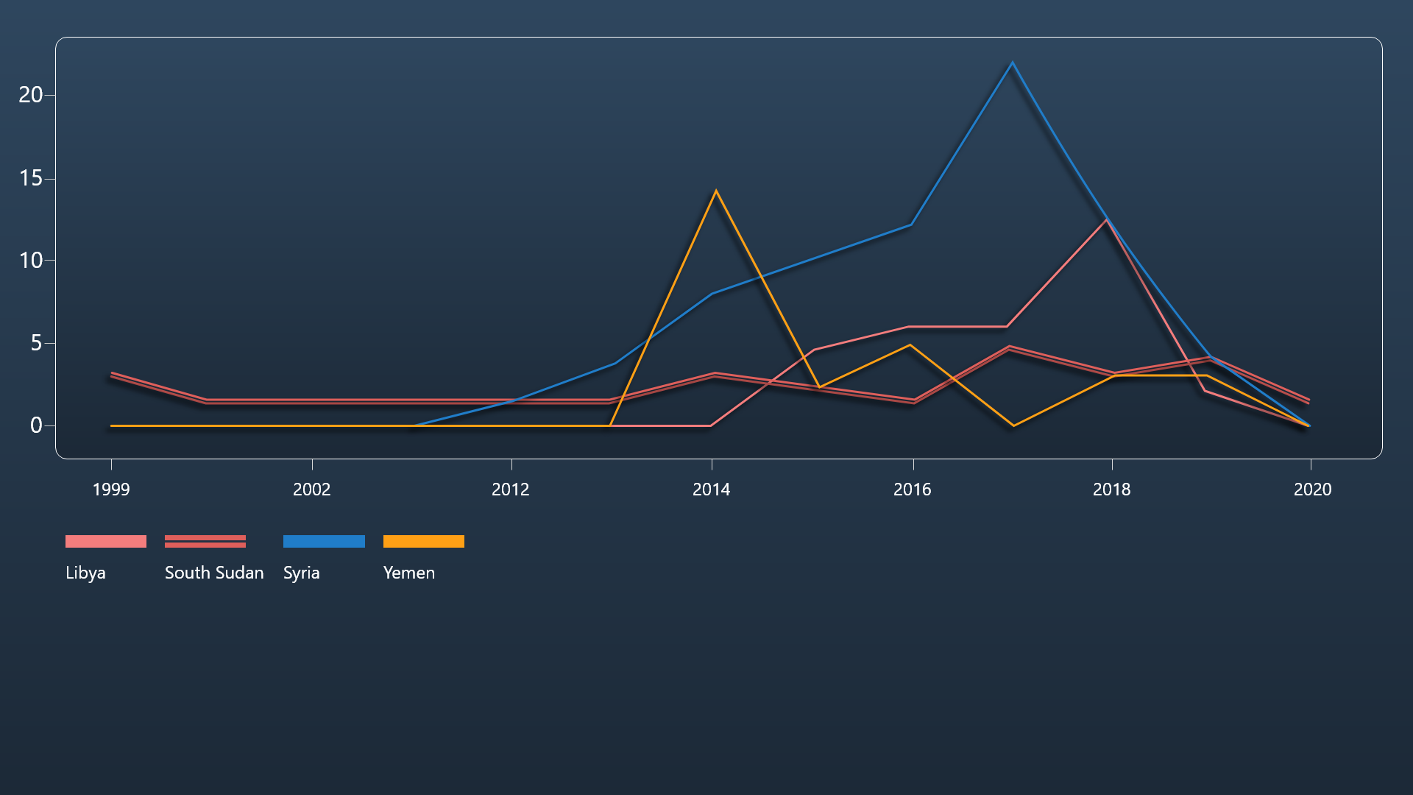

Fig.4 The number of local peace agreements in four countries (Syria, Yemen, Libya and South Sudan) signed in time order (1999- 2020).

For question2 (the impact of mediator). Gartner, S. S. (2011) championed the positive effects of mediation by regional organizations on conflict resolution. Zartman, I. W.(1985) reveal that the mediator usually plays three roles(communicator, formulator, manipulator) in signing local peace agreements, and after signing, mediators usually could sustain peace(Chong Chen). But we didn’t find much direct relationship between conflicts and number of local peace agreements have mediators.

For question3(the factors affect the type of mediator), we found there are three factors in could affect, respectively are the capacity of the insurgents, culture and economy. Clayton, G. (2013) suggests that relatively stronger insurgents are more likely to force the state to open a mediation process. Leng, R. J et.al (2003) argue that mediation is more likely to succeed when the parties are from similar social cultures.We have done some analysis of mediators in assignment 2 and found that different regions have different mediators, so we guess whether the choice of mediator will be influenced by culture, regional economy and state of national government. The second analysis is about the reasons why different mediators are chosen in different regions.

We mainly analyzed the influence of culture and economy on the types of mediators. In terms of culture, because one of the process types is Informal but persistent practice (PT_IPP), it represents a clear culture or practice of local peace agreement-making, so we use PT_IPP to verify the influence of culture on the mediator type. For economy, we use GDP as a symbol of economic strength. We mainly inquired about countries that signed peace agreements between 2016 and 2018 and used this to analyze the impact.(Fig.5&6)
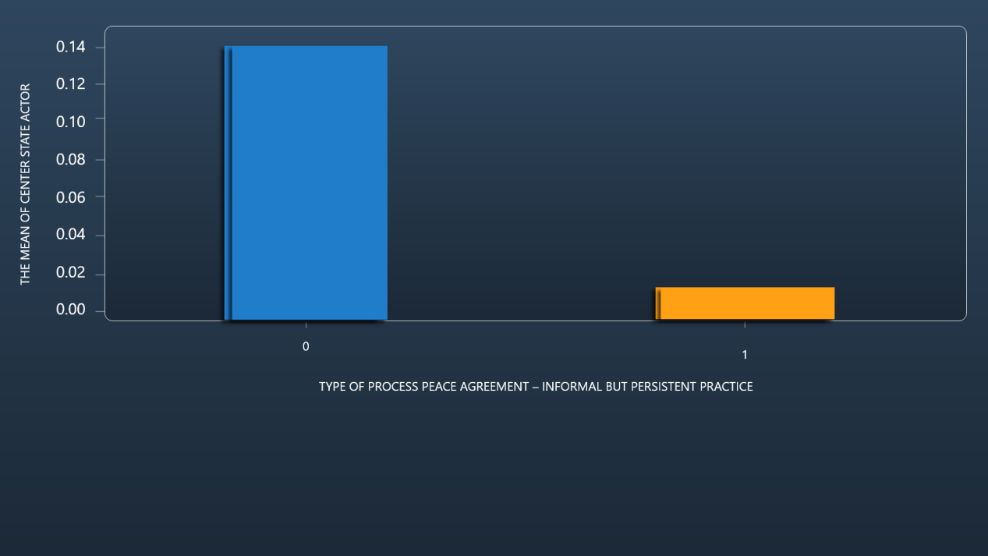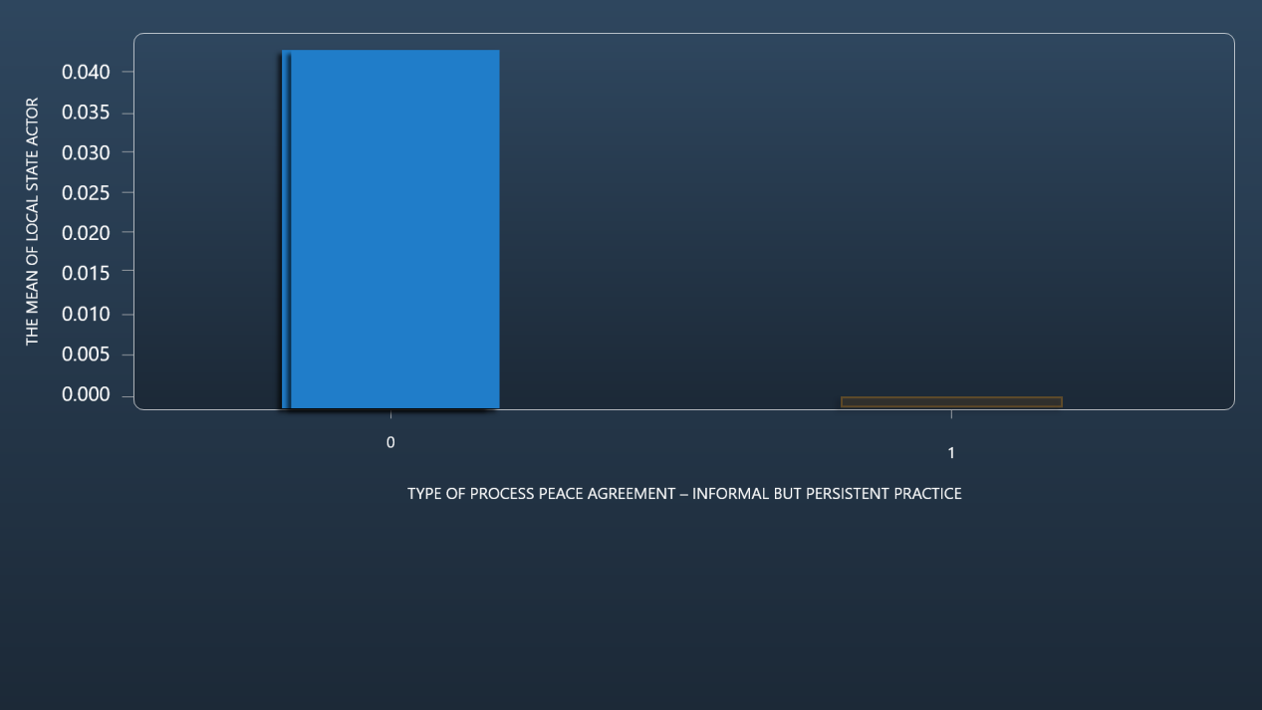
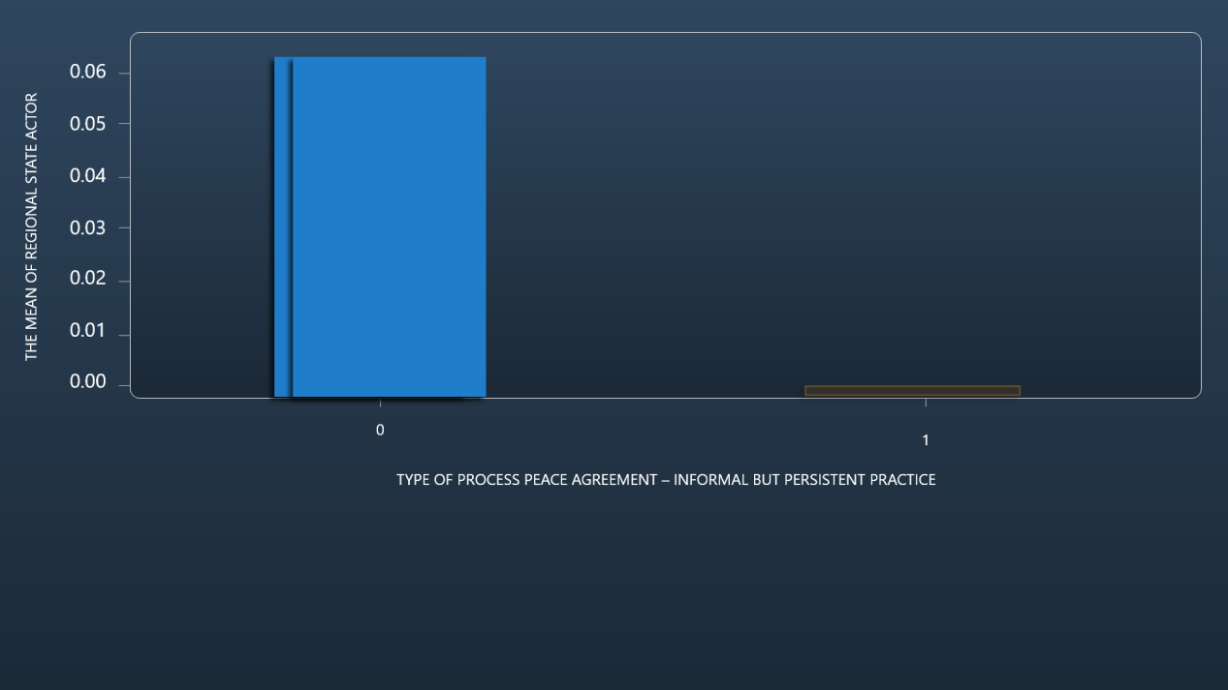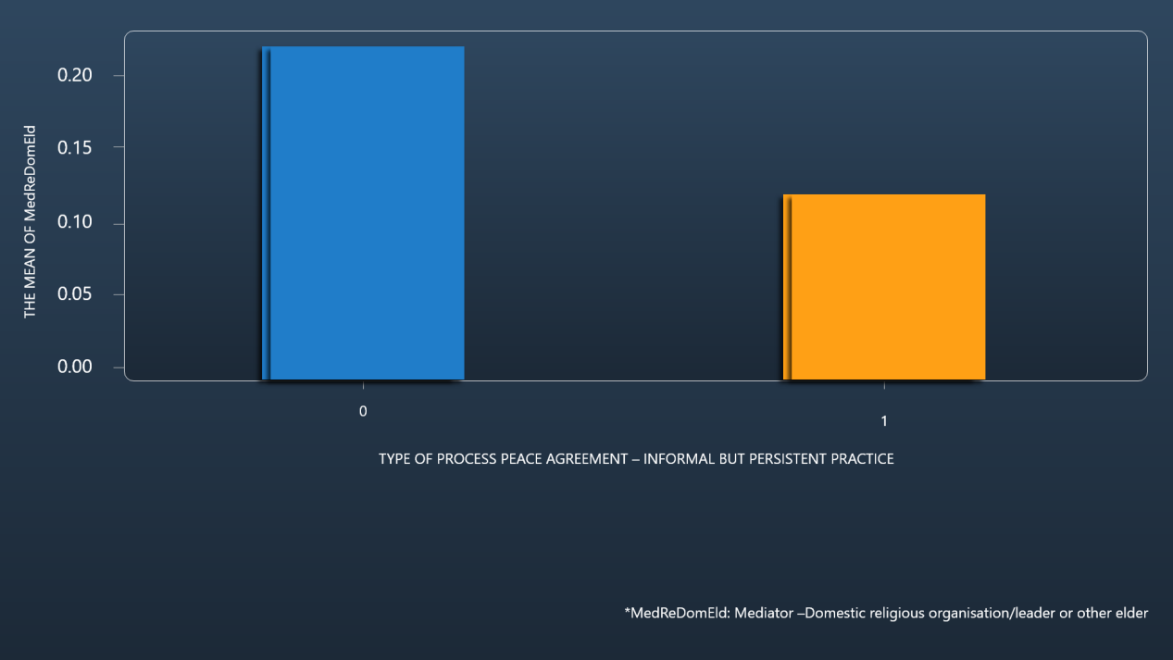
Fig.5 The impact to mediators(culture)

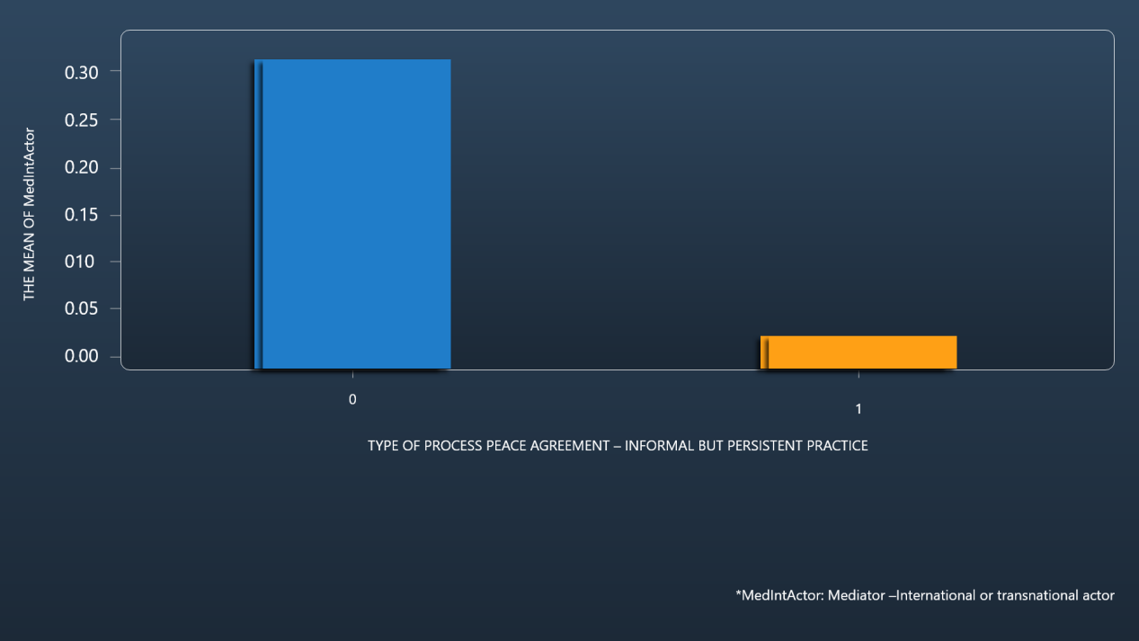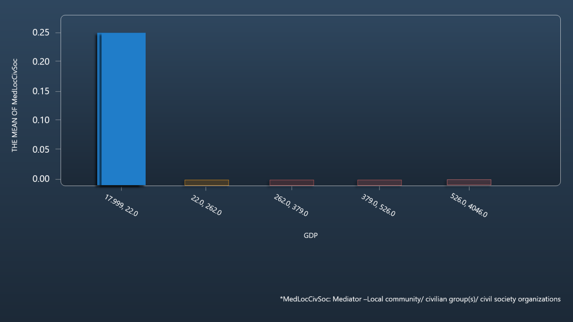
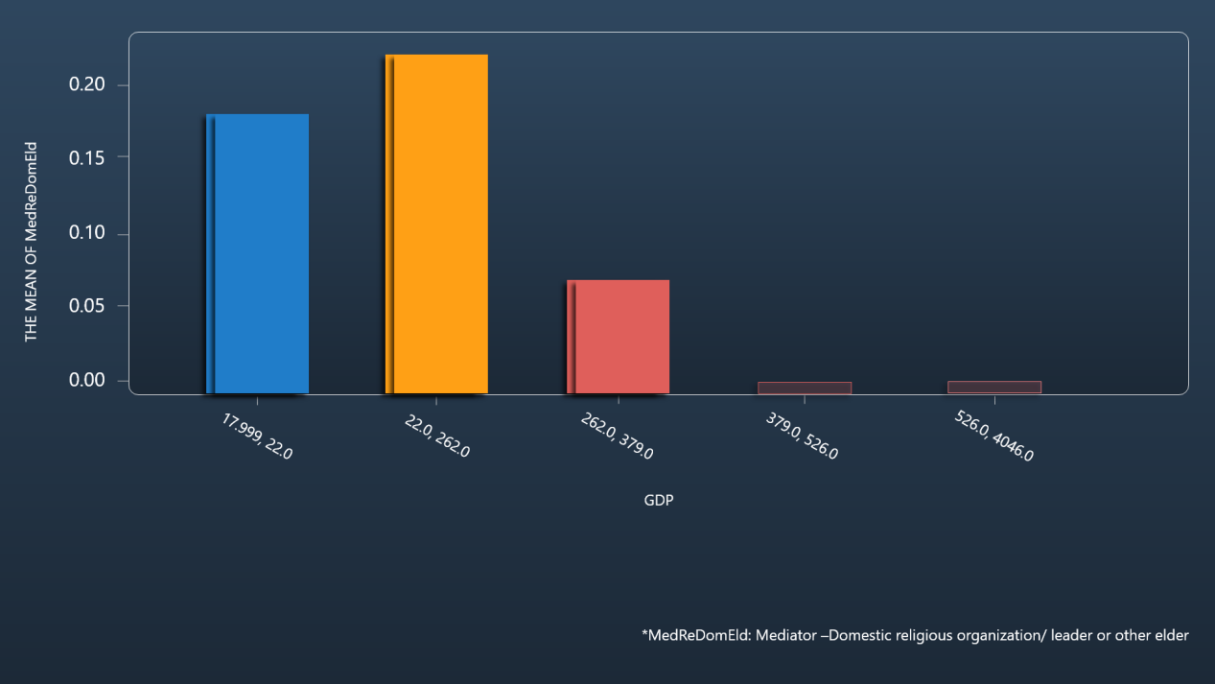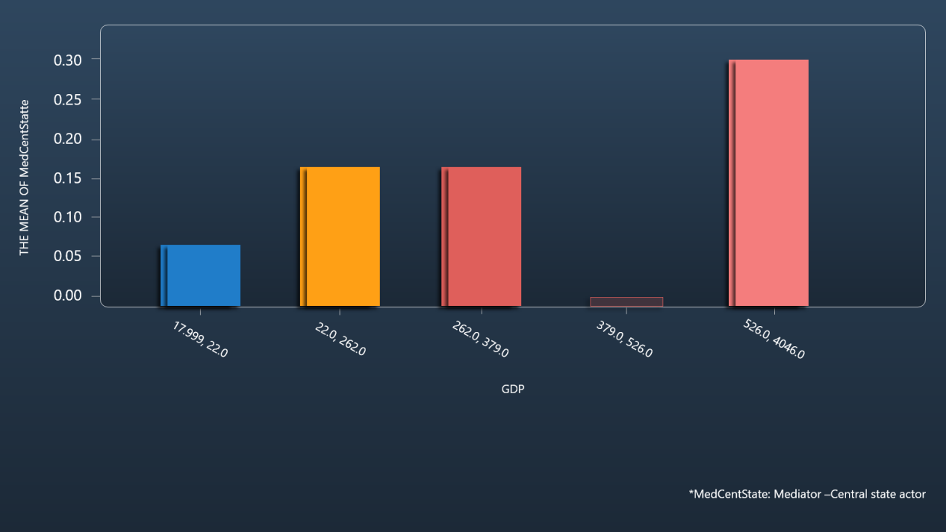
Fig.6 The impact to mediators(GDP)

Reflection
Nevertheless, it is undeniable that the civilians seek for peace and thus, by viewing our creation, we wish to spread the message of the significance of peace and hope to raise people’s awareness regarding this topic. We will add some conflict data in the future so that our users can more clearly compare the number and distribution of local peace agreements with local conflicts. Second, our analysis is focused on the Middle East, so there is a lack of regional news and analysis on the site. Finally, we want to add a search function that allows users to search whatever they want in our database.

Reference
- .DeRouen Jr, K., Ferguson, M. J., Norton, S., Park, Y. H., Lea, J., & Streat-Bartlett, A. (2010). Civil war peace agreement implementation and state capacity. Journal of Peace Research, 47(3), 333-346.
- Gartner, S. S. (2011). Signs of trouble: Regional organization mediation and civil war agreement durability. The Journal of Politics, 73(2), 380-390.
- Zartman, I. W. , & Touval, S. . (1985). International mediation: conflict resolution and power politics. Journal of Social Issues.
- Clayton, G. (2013). Relative rebel strength and the onset and outcome of civil war mediation. Journal of Peace Research, 50(5), 609-622.
- Leng, R. J., & Regan, P. M. (2003). Social and political cultural effects on the outcomes of mediation in militarized interstate disputes. International Studies Quarterly, 47(3), 431-452.
- Iff, A., & Alluri, R. M. (2016). Business actors in peace mediation processes. Business and Society Review, 121(2), 187-215.

